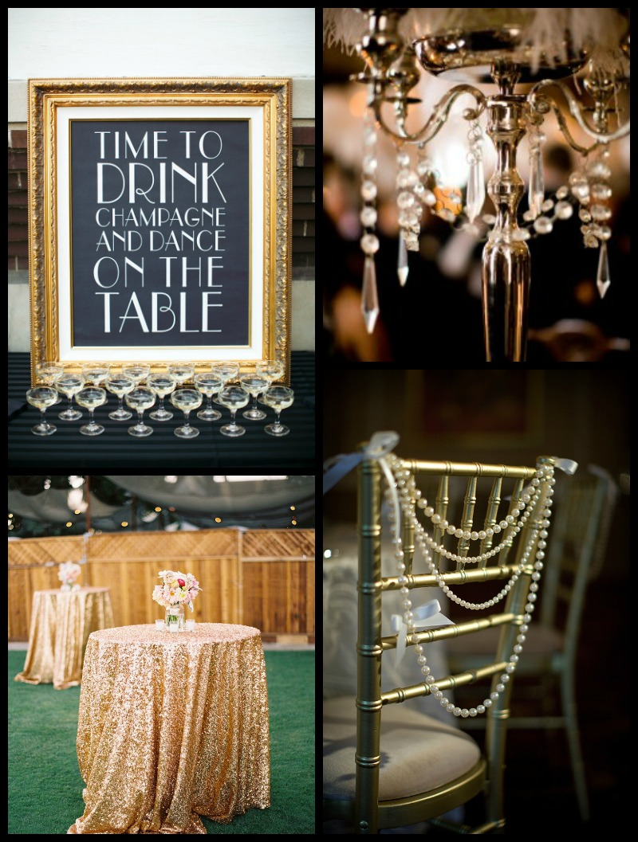

Great Gatsby Wedding Package Inclusions

Based on 75 Guests

Ceremony (Waterfront)
Professional Officiant
Arch Backdrop with Gold or Silver Sequin Fabric

Gold or Silver Chiavari Chairs
Feathers/Pearls Aisle Décor
Bouquets for Bride and Bridesmaids (up to 2)
Bouts for Groom and Groomsmen (up to 2)
Rose petals down aisle
Ceremony Coordinator

Reception (Indoor Venue)

Gold or Silver Sequin Tablecloths
Sweetheart Tablescape
Gold or Silver Candelabra Centerpieces
(Great Gatsby style)
Table Number Frames
Professional Dj
Professional Photographer for 4 hours
Wedding Cake
Reception Coordinator
Sparkler Send Off
Total Price 5,500.00

Venue Fees and One Entrée Dinner 3,500.00
Wedding Package Pricing Based on 75 Guests
Venue and Catering Based on 75 Guests
May add alcohol at Additional Cost
Indoor Venue holds up to 100 Guests
Outdoor Space holds up to 200
May add tent at additional cost
May add tent lighting at additional cost

