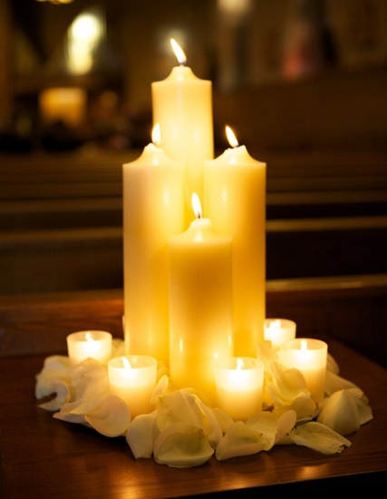

Cherished Ceremonies
www.cherishedceremonies.com
info@cherishedceremonies.com
813-877-6179

Beautiful Blessings Wedding Package Inclusiosns

Based on 75 Guests

Ceremony
Ordained Minister
Altar Candlelight Decor
Custom Aisle Décor
Ceremony Programs
Bridal Bouquet and Groom Bout
Up to 2 Bridesmaids Bouquets and Bouts
Ceremony Coordinator
Ceremony Music

Reception
Crystal Ice Chiavari Chairs
Custom Tablecloths in Any Color
Charger Plates in any Color

Centerpieces for all Tables
Sweetheart Tablescape in any Décor

Sign in and Gift Table Décor
Coordinating Table Number Frames
Wedding Cake
Reception Coordinator
Professional Photography
Professional Dj
Total Price 6,000.00

Venue and Catering Approximate Costs 3,500.00
Venue holds up to 150 Guests at Additional Cost

